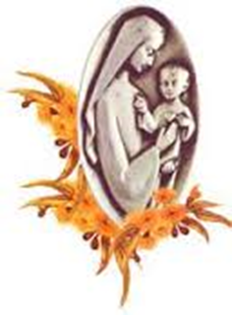





In his Encyclical *Laudato Si,* **Pope Francis** calls us to an **Ecological Conversion**.

“Your unique culture, experience, involvements, and talents are needed on our journey towards greater love for our Creator, each other, and the home we share”, said the Pope (LS 14).

He encourages us not to stay aside but to act, together with others, saying:

* When we give in to indifference, we block the working of God's Spirit, who always wants to give us new possibilities.
* When a people remembers its roots, it regains its ability to hope and change.
* Taking action starts with the realisation that you are not alone, but that you are part of a greater whole. When you discover that, you regain your ability to hope and change.
* Let us bring the whole human family together . . . for we know that things can change” (LS 13). Local individuals and groups can make a real difference (LS 179).
* When we respond to the call of *Laudato Si’*, with profound care for each other, our Creator, and all creation, we are building a better future together. In order to make change happen we need to talk and raise awareness about Laudato Si in meetings and liturgies.

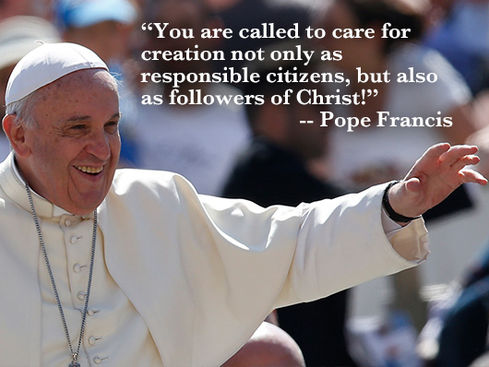

**As members and friends of the Chevalier Family**, we don’t want to stay behind. We are not alone. Within the Church we are part of a religious family, founded by Father Jules Chevalier MSC, who in his time already combatted indifference. He knew that fear paralyses, while love conquers all. Therefore, he gave us our motto:

**May the Sacred Heart of Jesus be everywhere loved.**

As an International Family we realize that:

* world solidarity is the radical alternative to the globalisation of self-interest and indifference.
* our choices show where our heart lies and that we, who live the Spirituality of the Heart, are called to adopt an attitude of love and care for Creation.
* the abstract disables people, while the concrete opens new possibilities.

Therefore, as members of the Chevalier Family, **I/we,……………………………………………..(name of individual or group)**

**Place……………………Country………………………………………………**

**make the following concrete promises:**

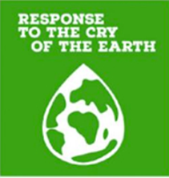**(Tick the items you can promise to do**

**during the coming year)**

**Concerning the Cry of the Earth:**

* to choose local or indigenous plants and shrubs to use in our gardens and on our properties.
* to promote bio-diversity by planting or sowing a variety of flowers to attract insects such as butterflies, bumblebees and bees.
* to avoid the use of chemical herbicides and insecticides.
* to pay attention to healthy soil and to use the principles of agro-ecology, while producing our own food.
* to protect waterways and land by ensuring sensible fertilizer use.
* to replace or decrease the use of fossil fuels by clean, renewable energy (e.g. using solar panels).
* other:……………………………………………………………………………………………………………………………………………………..……………………………………………………………………………...

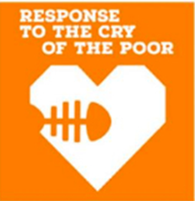

**Concerning the Cry of the Poor:**

* to ensure access to clean water for everybody and to train community members in hygiene practices.
* to combat stereotyping of migrants and refugees by promoting a culture of openness and encounter.
* to promote and protect Indigenous leadership by ensuring Indigenous

communities have the rights to their land and by elevating Indigenous

leadership.

* to use our media channels to lobby leaders for the defence of human rights of marginalized groups.
* to grow in solidarity with vulnerable people by doing an audit of

community challenges, delivering programs to address basic needs, and

delivering programs to address failed systems.

* to join movements and to collaborate with networks to address root causes of poverty (advocacy).
* other:……………………………………………………………………………………………………………………………………………………..……………………………………………………………………………...

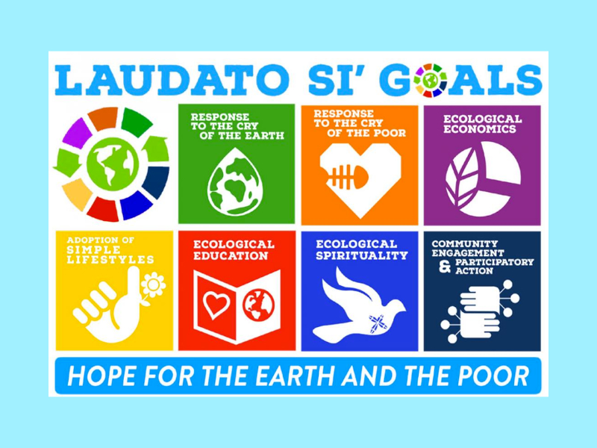

**Concerning Ecological Economics:**

* to buy food from local farmers (short chain) and to opt for (organic) seasonal products from our own country.
* to support the local economy and preferably to buy the products that are produced in our neighbourhood.
* to choose Fair Trade products for coffee, tea, chocolate and bananas.
* to make a personal and public commitment not to use brands we know are exploiting people, land, children and environment.
* to ensure financial investments are ethical and sustainable by divesting

from fossil fuels, investing in socially responsible enterprises, and

choosing ethical banking and insurance companies.

* other:…………………………………………………………………………………………………………………………………………………………………………………………………………………………………



**Concerning Adoption of sustainable lifestyles in order to reduce our ecological footstep**

* **To Reduce**
* to consume less, thus obliging manufactures to produce less.
* to choose clothing of materials that are long lasting, like cotton.
* not to leave on unnecessary lights, inside or outside and to turn off the lights when we leave a room.
* not to charge our mobile phones longer than necessary.
* after use, to unplug the electrical appliances that have a stand-by function, in order to avoid standby consumption.
* to regularly check for leaking taps, showerheads and toilets and to let the necessary repairs be done as soon as possible.
* not to use several cars for trips and excursions with a larger group, but to rent a bus: to encourage the use of public transport.
* to ban single-use plastics, to avoid plastic bags and other packaging waste when purchasing and not to use disposable cups, plates or cutlery.
* to avoid buying over-packaged materials of food.
* to reduce food waste by avoiding to buy more food than needed; by using up all the food purchased before buying more; by storing food correctly and using up any leftovers.
* other:…………………………………………………………………………………………………………………………………………………….……………………………………………………………………………..

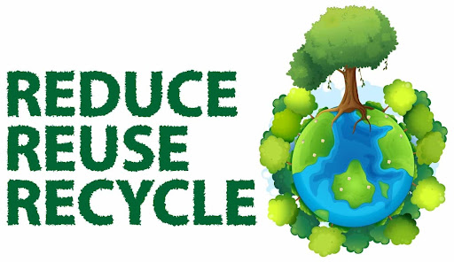

* **To re-use:**
* to collect rainwater to use as drinking water for the chickens, for cleaning, watering the plants inside and outside, flushing the toilet, etc...
* to use recycled paper and envelopes; to use paper sparingly and reuse scrap paper for example by making notebooks out of it.
* to give away the things we don’t need any longer instead of throwing them in the waste bin.
* to use second hand articles.
* to compost leftover food and thus turning food waste into energy for plants.
* other:………………………………………………………………………………………………………………………………………………………………………………………………………………………………
* **To recycle:**
* beverage bottles, paper, ink cartridges
* to avoid, as much as possible, non-recyclable products.
* other:…………………………………………………………………………………………………………………………………………………………………………………………………………………………………



**Concerning Ecological Education**

* to follow in the news (papers, television, radio) what is said about environmental issues.
* to foster ecological conversion by changing our attitude , heart and mind and decide to do things differently, out of freedom and not out of duty.
* to develop *Laudato Si*’ learning opportunities by including *Laudato Si*’ in our formation plans and to ensure that members of the community are familiar with the local ecosystem, the science and social dimensions of the ecological crisis, and ecological virtues.
* to ensure education is community-led by creating ways for educators to

undergo ecological conversions, creating opportunities for youth-led

events, and developing mechanisms to publicly recognize young people

for their leadership

* to encourage community reflection on *Laudato Si’* themes by having the community leader or community members speak about them, including them in the celebration of liturgical moments, and making study and prayer guides available.
* to weave *Laudato Si’* themes into the community's communications by

regularly highlighting them in newsletters/bulletins and on social media

and by encouraging community members to work on the *Laudato Si* goals.

* to deliver equitable access to education by ensuring under-represented

groups are educated, sharing education programs with a wide variety of

people, offering culturally appropriate and/or alternative forms of

education, and ensuring that education promotes human rights and

dignity.

* to teach toddlers in kindergarten how to avoid pollution (disposal of paper, plastics, etc.) and to teach pupils and students the need for gratitude and responsibility for the environment around them.
* other…………………………………………………………………………………………………………………………………………………….……………………………………………………………………………...



**Concerning Ecological Spirituality, in order to be good stewards of creation**

* to speak in our liturgy regularly of God as our creator, the one who made all of creation; to praise and thank God for nature, creatures and the world God made; to ask for forgiveness for times when we harm God’s gift of creation and to pray for the healing of our environment.
* to organize outdoor celebrations like a cemetery Mass, a Mass at a Holy Well, local pilgrim walks or stations of the cross; to use natural materials within worship.
* to celebrate the Season of Creation.
* to continue to study *Fratelli Tutti* and *Laudato Si* and its connection with our own Spirituality of the Heart.
* to take part in the first Friday action of the Chevalier Family as a way to express solidarity and to grow in awareness through prayer & action.
* other:……………………………………………………………………..................................................................................................................................................................................................................................................



**Concerning Community Engagement and Participatory Action**

* once a year to share our experience with the Chevalier Family in a short report to be published in our JPIC Bulletin.
* to learn to know the organisations in our neighbourhood and what they are doing; to keep in touch with them.
* to participate in their campaigns and initiatives for the environment.
* to advise our town or city council on sustainable initiatives they can take, e.g. the layout of the streets, flower campaigns, traffic safety and making the neighbourhood a low-traffic area, public greenery, the use of the square, the establishment of a Neighbourhood Point, etc.
* other:…………………………………………………………………………………………………………………………………………………….……………………………………………………………………………..

The encyclical letter *Laudato Si* offers us a clear road map for learning how to live the hope expressed in Is 43,19: “Behold I am doing a new thing: now it springs forth, do you not perceive it? I will make a way in the wilderness and rivers in the desert”.

In his encyclical letter *Spe Salvi* Pope Benedict XVI wrote: “The Christian message was not only ‘informative’ but ‘performative’. That means: the Gospel is not merely a communication of things that can be known – it is one that makes things happen and is life-changing. The dark door of time, of the future, has been thrown open. The one who has hope lives differently” (SS. 2).

If our community involvement and participatory action teach us to “discover the worth of everything, to be filled with awe and contemplation, to recognize that we are profoundly united with every creature” (LS 246) then our struggle for JPIC, however simple, will bear fruit in the right time.

**Twice a year, I/ We will conduct a self-evaluation of our progress in working on the promised issues and make new resolutions.**



Date:…………………………… Signature:………………………………….

Name:………………………… Email address:……………………………..

Please, send your declaration

For the MSC Sisters to: the JPIC Promoter of your Unit.

For the FDNSC to: [gensec@](mailto:genolsh@gmail.com)olshgen.org

For the MSC to: [secgen@msc-chevalier.org](mailto:secgen@msc-chevalier.org)

For the Laity of the Chevalier Family to [alisonmckenzie@chevaliercentre.org](mailto:alisonmckenzie@chevaliercentre.org)

Or [dmsdoris@gmail.com](mailto:dmsdoris@gmail.com)

Or [rit.cleuren@hotmail.com](mailto:rit.cleuren@hotmail.com)